Interface Control Document - AT30TSE75# Temperature Sensor (Content Exam Extra Credit)

10/17/2024 Reese Ford

# Specific Order of Signals

1. Set Pointer to Configuration Register AND Write to the Configuration Register, setting the Temperature Resolution to 10-bits
   1. 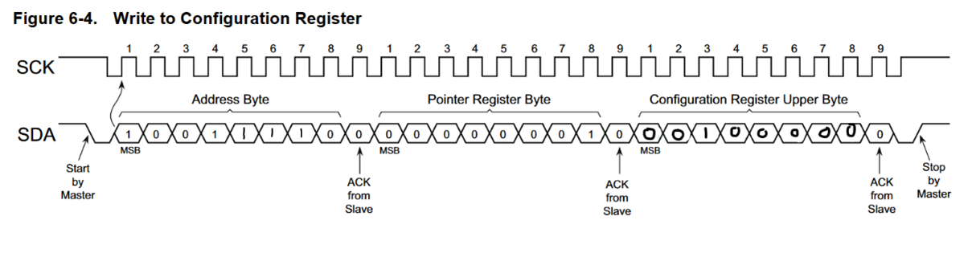
   2. 10011110 00000001 00100000
2. Convert Temperature to 10-bit register value
 $R=0.25$

 $B_{temp}=\frac{D_{tempC}}{R}$

 1. Convert $B_{temp}$ to binary
   2. $T_{LOW}$ or $T_{HIGH}=B_{15}:B_{6}$
$B_{5}:B_{0}=0$

3. Set $T_{LOW}$ to $24.75°C$ using Step 3
   1. 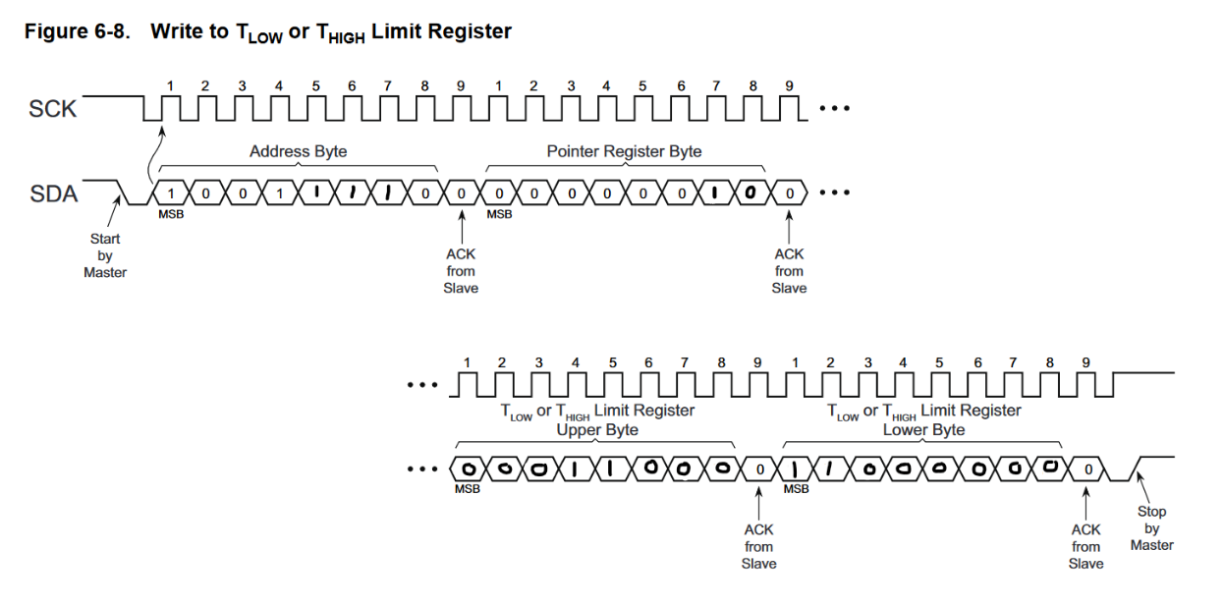
   2. 10010000 00000010 00011000 11000000
4. Set $T_{HIGH}$ to $30.25°C$ using Step 3
   1. 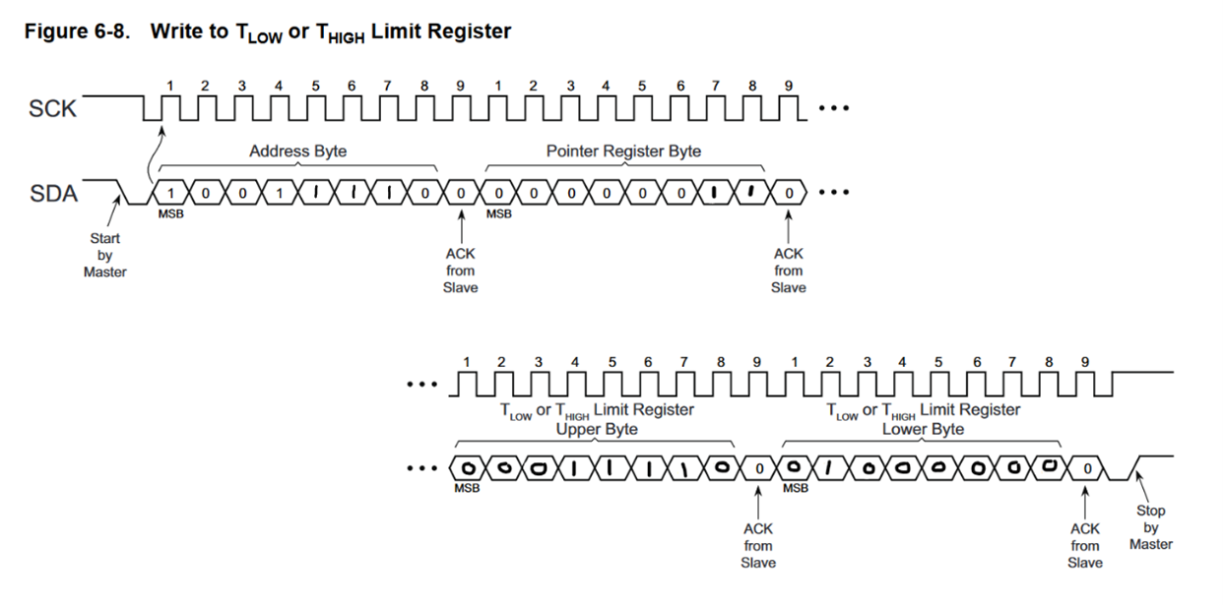
   2. 10010000 00000011 00011110 01000000

# Question(s) from Problem

Pin EXT_9 on the IO board is for the Temp Alarm Signal, so setting up an EIC interrupt for EXT2_PIN_9 will allow us to detect a temperature “fault”. If the pin goes high, that means the temperature has either exceeded the $T_{HIGH}$ temp or fallen below the $T_{LOW}$ temp. When the pin goes high, it will trigger an EIC interrupt.